EX 1

Toy Problem

**Harsh Saxena**

**RA1911033010060**

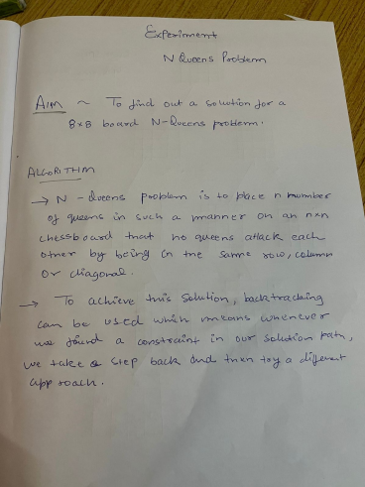

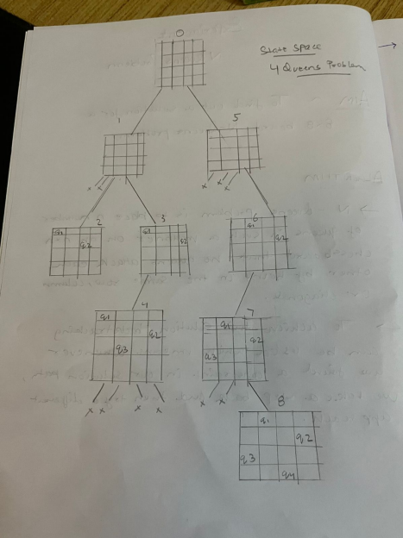

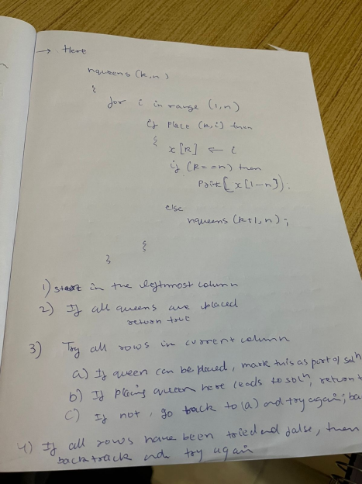

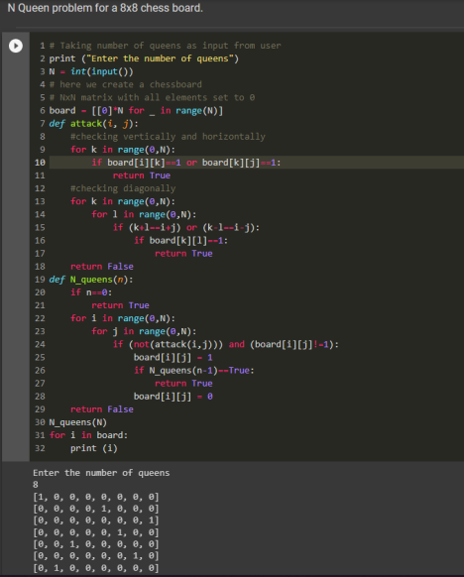

**# Taking number of queens as input from user**

**print ("Enter the number of queens")**

**N = int(input())**

**# here we create a chessboard**

**# NxN matrix with all elements set to 0**

**board = [[0]*N for _ in range(N)]**

**def attack(i, j):**

**#checking vertically and horizontally**

**for k in range(0,N):**

**if board[i][k]==1 or board[k][j]==1:**

**return True**

**#checking diagonally**

**for k in range(0,N):**

**for l in range(0,N):**

**if (k+l==i+j) or (k-l==i-j):**

**if board[k][l]==1:**

**return True**

**return False**

**def N_queens(n):**

**if n==0:**

**return True**

**for i in range(0,N):**

**for j in range(0,N):**

**if (not(attack(i,j))) and (board[i][j]!=1):**

**board[i][j] = 1**

**if N_queens(n-1)==True:**

**return True**

**board[i][j] = 0**

**return False**

**N_queens(N)**

**for i in board:**

**print (i)**